**Coffee AI Tools**

#### [**Demetria**](https://demetria.ag/)

Demetria, an Israeli-Colombian agritech startup, developed a data intelligence platform powered by AI that matches each coffee bean profile with the industry-standard coffee flavor wheel. The solution comprises a handheld near-infrared (NIR) spectrometer and a machine learning algorithm that assesses the chemical composition of green coffee beans. The spectrometer measures various parameters such as bean size, weight, and humidity levels, relaying this information to a mobile app developed by Demetria. The NIR sensors provide a chemical "fingerprint," which the algorithm maps to the eventual taste of the coffee post-roasting and brewing in the app.The organized data is then compiled into a quality and traceability data cloud, created by collecting insights from Q Graders.

* **Problem:** The coffee industry often lacks a consistent and objective way to assess coffee bean quality before the roasting process.
* **Solution:** Demetria's AI-powered platform analyzes green coffee beans to predict their flavor profile.
* **Key Components:**
  + Handheld near-infrared (NIR) spectrometer to measure bean characteristics.
  + Machine learning algorithm to link the chemical composition to taste.
  + Mobile app to deliver the analysis.
  + Data cloud for quality assessment and traceability.
* **Benefits**
  + Improves quality assessment for all players in the coffee supply chain.
  + Increases transparency and traceability for the industry and consumers.

#### [**Csmart**](https://www.csmart.ai/)

Brazil-based agritech startup Csmart specializes in automating specialty coffee processes through cutting-edge technology. Their flagship product, Csmart Digit, employs computer vision, AI, and data analysis. The device, equipped with features like an automatic electromagnetic feeder, integrated LED lighting, and a high-speed CMOS camera, allows users to classify green coffee, extract quality data, and generate grading reports. The AI software within Csmart Digit provides in-depth analysis, batch evaluations, and custom databases, promoting traceability and providing defect prediction. Through continuous flow system integration, Csmart Digit can also assess machine efficiency for quality compliance.

* **Product:** Csmart Digit, an AI-powered device for green coffee grading and analysis
* **Technology:**
  + Computer vision
  + Artificial intelligence
  + Data analysis
* **Features:**
  + Automatic feeder
  + High-speed camera
  + Integrated lighting
* **Functions:**
  + Classifies green coffee beans
  + Extracts quality data
  + Generates grading reports
  + Analyzes batches
  + Creates custom databases
  + Predicts defects
* **Benefits:**
  + Promotes traceability
  + Ensures quality compliance
  + Improves efficiency

#### [**Agrivero**](https://agrivero.ai/)

Agrivero, a Germany-based start-up, has recently developed an AI-enabled solution designed for green coffee grading. The process involves loading samples of up to 500 grams of green coffee into the VeroLab device. VeroLab then utilizes a high-resolution camera, AI and Computer Vision to individually scan and analyze each green coffee bean from both sides. Results are available within 4 minutes on both the device's screen and the Agrivero Web App, offering analytical insights for efficient decision-making in the green coffee grading process. Users may also use the Agrivero device offline. The company is currently developing an API and integrations into popular ERP systems.

* **Product:** VeroLab device for AI-powered coffee grading.

**How it Works:**

* **Input:** Load up to 500 grams of green coffee.
* **Analysis:** High-resolution cameras with AI and computer vision scan each bean individually.
* **Output:** Rapid results (within 4 minutes) available on the device and Agrivero Web App, providing in-depth analysis.

**Key Features:**

* **Offline Functionality:** Device works even without internet connection.
* **Data Accessibility:** API and integrations with major ERP systems in development.

**Primary Benefit:** Simplifies and improves accuracy of green coffee grading, aiding decision-making throughout the supply chain.

#### [**ProfilePrint**](https://profileprint.ai/)

ProfilePrint, a Singapore-based AI-powered food fingerprint platform, utilizes molecular analysis to predict sensory profiles in green coffee samples. Requiring just 50 grams of coffee beans, the platform scans and generates a comprehensive digital report, including cupping scores and sensory parameters. By employing a wide range of wavelengths of light, covering both the visible spectrum and the NIR spectrum, ProfilePrint creates a unique fingerprint for each sample. This spectral data is fed into an AI algorithm, facilitating early-stage assessment of cupping scores, as well as flavor profiles.

* **Technology:** Predicts coffee bean sensory profiles using molecular analysis.

**Process**

* **Input:** Small sample required (only 50 grams of green coffee beans).
* **Analysis:** Wide spectrum light scanning (visible and NIR) creates a unique molecular fingerprint.
* **AI Algorithm:** Processes the fingerprint to provide early-stage predictions of:
  + Cupping scores
  + Flavor profiles

**Benefits**

* **Accurate and efficient:** Provides a rapid and data-driven way to gauge coffee quality.
* **Reduces waste:** Small sample sizes minimize the need for extensive bean usage in assessment.

**GPTs**

[**Coffee GPT**](https://github.com/yasinguness/coffee_gpt)

Coffee GPT, it is a mobile application that makes order suggestions to customers and allows customers to order easily and quickly.

[**Barista GPT**](https://www.baristagpt.com/)

BaristaGPT revolutionizes customer engagement with AI-powered menu insights, custom-branded chat widgets, and seamless Point of Sale integration for a streamlined café experience.

[**Speciality Coffee & Cocktail Guide GPT**](https://chat.openai.com/g/g-pp9c58OKg-speciality-coffee-cocktail-guide-gpt)

GPT - Tailored guide for coffee, cocktails, and local events.

[**Pocket Barista (Coffee Guide)**](https://chat.openai.com/g/g-3HShFYkCM-pocket-barista-coffee-guide)

I'm here to help you make the perfect coffee.

**Coffee Apps**

**Tastify**

Taste database manager for coffees, flavor profile creator

[**https://www.tastify.com/**](https://www.tastify.com/)

**Catador** replicates the industry standard SCAA coffee cupping scoresheet with an easy-to-use system of sliders to rate sensory criteria and tick boxes to mark off-cups in the categories of Uniformity, Clean Cup and Sweetness.

[**https://play.google.com/store/apps/details?id=gt.com.cs.catador&pli=1**](https://play.google.com/store/apps/details?id=gt.com.cs.catador&pli=1)

[**https://www.flavrite.com/**](https://www.flavrite.com/)

**Take photo of products and get recommendations. Rate flavors of coffees, teas, chocolates, cheese. Trending products leadserboard**

**Arduino and DIY Coffee maker Firmware**

<https://gaggiuino.github.io/#/guides-stm32/lego-component-build-guide?id=general-install-info>

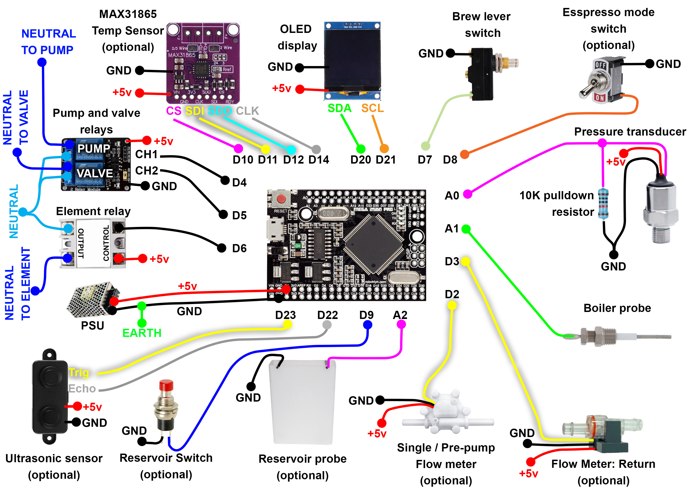

Wiring for Smart Coffee Sofware

<https://www.schematix.co.nz/product-page/smart-coffee-software>

**Smart coffee** is highly customizable software that runs on an Arduino or similar microcontroller, to control the various functions of an espresso machine.

### **Smart Coffee Machine - Ősi Gyula**

Smart automatic Coffee Maker with Graph, can be controlled via Bluetooth... or just load fresh water, and the system will start automatically!

<https://www.hackster.io/gyula-osi/smart-coffee-machine-with-arduino-and-bluetooth-6870d0>

Smart Coffee Vending Machine with Arduino

<https://www.theengineeringprojects.com/2021/11/smart-coffee-vending-machine-using-arduino.html>

1. Arduino UNO
2. LCD display
3. 4 Buttons
4. 8 Motors
5. PCF8574

**Deep Brew**

<https://www.linkedin.com/pulse/starbucks-magic-artificial-intelligence-enhancing-coffee-pavithra-s/>

Starbucks now has a special AI program called Deep Brew, which helps personalize customer experiences, manage stores efficiently, and make sure they always have your favorite drinks in stock.

* Product:
* In 2011, Starbucks launched a mobile app that collected data about their customers.
* Deep Brew is more like an invisible, super-smart sidekick to the human baristas helping do the heavy lifting with inventory, supply chain logistics and replenishment orders, saving partners’ time, predicting staffing needs and making schedules. It can also help with predictive maintenance, giving staff a heads up before a coffee machine breaks down.
* Input:

At least include the data on customer spending and preferences, the history of orders and patterns.

* Analysis:

Data analytics and AI. It does not involve computer vision or other sensor techniques.

* Functions:
* Personalized recommendations based on past orders and preferences
* Real-time notifications when a customer is near a store or when their favorite drink is available.
* New and innovative products that match customer preferences and stay ahead of the competition.
* Assist with inventory management, supply chain logistics, and staffing needs.
* Benefits:
* Use AI and Machine Learning to personalize customer experiences, optimize store operations, and manage inventory.
* Help Starbucks understand what customers like, so they can offer personalized suggestions, promotions, and unique experiences.
* Ensures efficient service by optimizing store staffing and predicts inventory needs to prevent running out of popular items.
* Grow the customer base and making loyal fans.

**Artly barista bot**

<https://artly.coffee/>

Artly uses artificial intelligence to control specialized robots and make very good coffee. It may not be that relevant to our project, but it also involves some useful AI techniques. Artly set out to design a robot that could make coffee like a human, without sacrificing quality. It was primarily trained by reigning US barista champ, Joe Yang, but it keeps learning more from the baristas who train it. The focus of Artly is to mimic human operations.

* Techniques:

Deep learning AI and computer vision

* Functions:

Anomaly detection, Structure from motion, Obstacle avoidance, Path planning, Physical reasoning

* Benefits:

Deep Learning-based visual inspection is used to monitor drink quality at each step to ensure a perfect cup with every order.

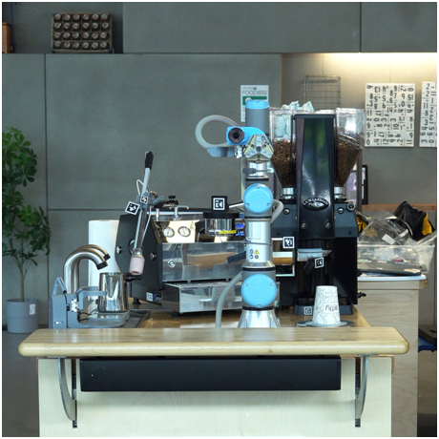

**FlavorPrint**

Vivanda’s AI technology, called FlavorPrint, maps consumers’ preferences across a diverse range of tastes and aromas. This helps better understand and respond to consumer preferences, driving informed product development. It is not only for coffees, but it provides a lot of information that helps design app interface, such as

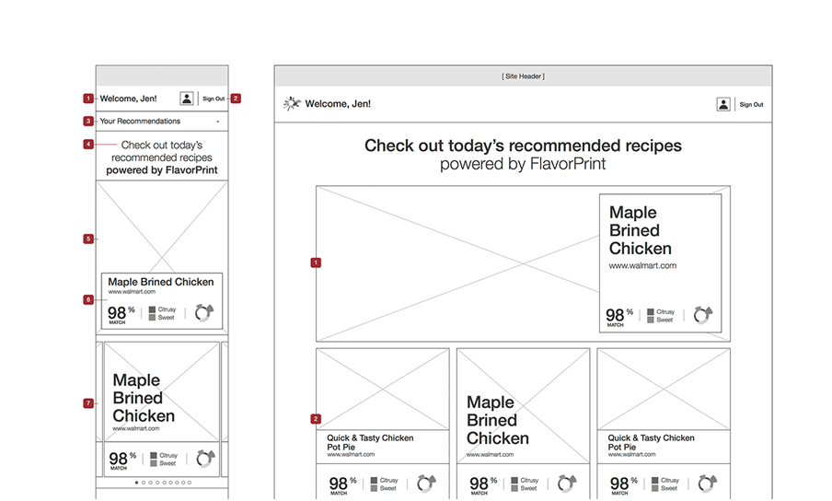

For more images, see the link

<https://www.gabriellewilliams.net/mccormick-flavorprint-20>

**Eagle One VIS**

<https://victoriaarduino.com/eagleone/>

VIS is a virtual scale based on an artificial intelligence algorithm that favours even faster workflow than the previous version of Eagle One and dose monitoring for every shot. VIS is exclusive Victoria Arduino technology that was developed to digitally estimate the right dose in the cup using an algorithm calculation. On the display, just set the desired weight in grams and VIS automatically monitors the flow to obtain the right dose in the cup.

* Function:

Monitor the dose, quarantee the quality, and reduce the waste.

* Input:

Set the desired weight in grams.

**AiO roaster**

**I think this may be the closest to what we want to do.**

Aillio’s AiO roaster is designed to become smarter as more users engage with the system, leveraging collected data through machine learning.

<https://aillio.com/?page_id=31830>

* Functions:
* You can monitor the bean temperature and its Rate of Rise while tweaking analog knobs to change drum speed, heating, and fan with precision.
* You can also control the machine from nearly any internet-ready device, including tablets and smart phones. You do this via our RoasTime for AiO software.
* RoasTime software will automatically plot your “roast profile” — a visual representation an individual roast that is fundamental to data-driven roasting techniques. By recording changes made during the roast and graphing bean temperature over time, these roast profiles offer a great deal of insight into your techniques, and ultimately can be converted into “roast recipes”.
* Roast recipes and roast profiles are automatically synced to our cloud service, Roast.World, which is an online community specifically for Aillio users.
* At Roast.World, you can analyze past roasts, manage your bean inventory, discover new bean vendors, search for other users, and download profiles and recipes from them.
* If you would like, you can create your own recipes from scratch, with no other inputs.
* Analysis:

On a local level, we can use AI to automatically adjust for small variations between your machine and the ‘mean’ performance of all connected AiO machines. Everyone’s roasting setup is unique in some small ways — local ambient temperatures, insulation, barometric pressure, and variations within machine tolerances — but these can be averaged, and the AiO’s performance tweaked to approach the mean, making the automatic playback of other people’s roasts — or even your own under changing circumstances — even more accurate.

* Brewing techniques, except for AI

Induction Heating, patented infrared temperature sensor (IBTS), Air Heating and Chaff Collection.

* Benefits:

Save money, save time, and roast responsibly.

